1. Introduction
1.1 Background
In the modern digital economy, financial fraud has evolved from simple physical theft to sophisticated cyber-attacks. As transaction volumes grow, traditional manual auditing becomes impossible. Machine learning has emerged as a critical tool for automating detection. However, most current systems operate as "black boxes" they flag transactions without explaining the underlying behavioral patterns. Understanding why fraud occurs is just as critical as detecting if it occurs [1].
1.2 Problem Definition
The primary issue this study addresses is the "Monolithic View" of fraud. Existing systems often treat all fraudulent activities as a single class, failing to distinguish between different typologies (e.g., high-value anomalies vs. technical network compromises). Furthermore, there is a gap in interpretability; banks know a transaction is bad, but often lack the insight to know which specific feature (IP, Device, or Amount) triggered the alert.
1.3 Existing Solution
Current solutions predominantly rely on supervised binary classification (e.g., Logistic Regression or SVM). While accurate, these require heavy labeling and often miss emerging, novel fraud patterns that do not fit pre-trained historical data.
Objectives
- To identify natural groupings of transaction behaviors using unsupervised K-Means Clustering.
- To validate these groups and determine the primary drivers of fraud using Random Forest Classification.
- To provide a deciphered profile of fraudulent entities based on technical and behavioral features.
Scope and Limitations
This study utilizes a synthetic dataset of 10,000 transactions. While modeled after real-world banking logs, the data is cleaner than actual production data, which may result in higher-than-average accuracy metrics. The analysis focuses on technical risk scores and transaction metadata.
2. Materials and Methods
2.1 Dataset Description
- Source: Synthetic Fraud Dataset (uploaded for research experimentation) [2].
- Size: 10,000 rows, 10 attributes.
- Key Attributes: amount (Float), hour (Integer), device_risk_score (Float), ip_risk_score (Float), is_fraud (Binary Target).
2.2 Exploratory Data Analysis (EDA)
- Data Preparation:
  - Cleaning: Checked for null values (0 found).
  - Encoding: Categorical variables (transaction_type, country, merchant_category) were converted to numeric values using Label Encoding.
  - Normalization: Numerical features were scaled using StandardScaler to ensure large transaction amounts did not bias the clustering distance metrics.
- Distribution of Key Features: The dataset is highly imbalanced, with 95% Legitimate transactions and 5% Fraudulent transactions.
Visualization: A correlation heatmap was generated to inspect relationships.
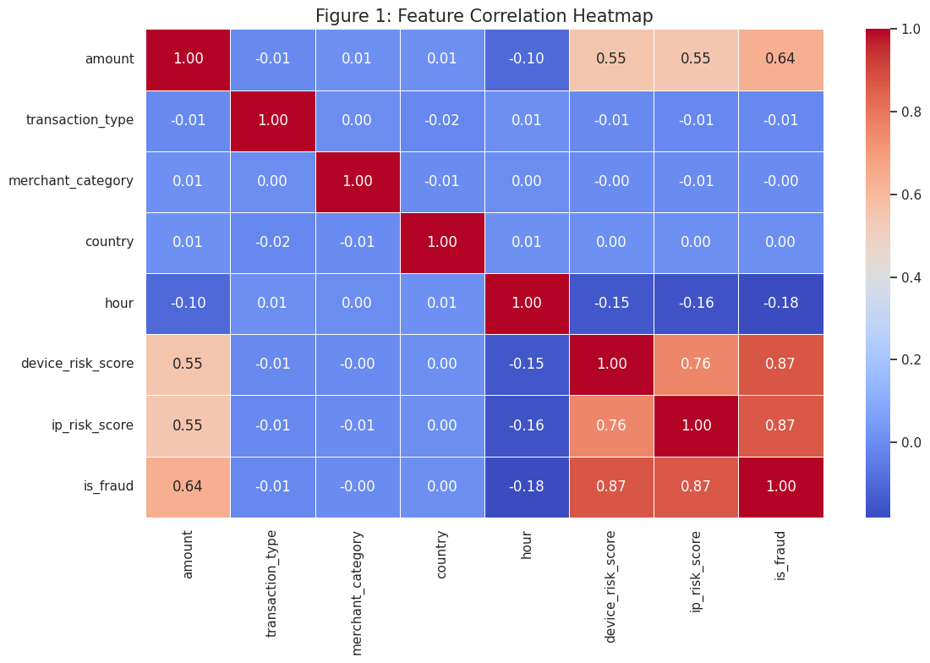
Figure 1: Feature Correlation Heatmap
Outlier Detection: Boxplots revealed that fraudulent transactions consistently exhibited extreme outliers in amount and risk_scores.
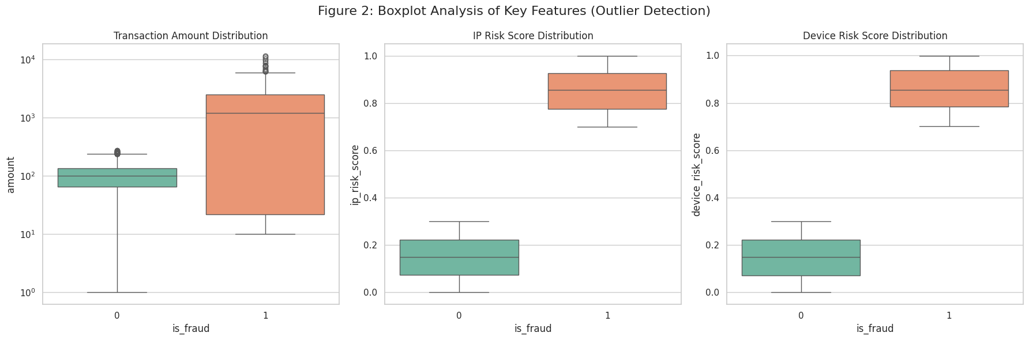
Figure 2: Boxplot Analysis
2.3 Models
2.3.A Clustering
- Algorithm Used: K-Means Clustering.
- Formula: The algorithm minimizes the Within-Cluster Sum of Squares (WCSS) using Euclidean distance:
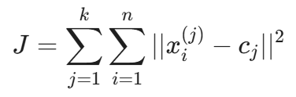
Where Xi is a data point and Ci is the cluster centroid.
- Parameters Chosen:
  - K = 2 (Determined via the Elbow Method).
  - Distance Measure: Euclidean.
- Metrics: Silhouette Score (measures how similar an object is to its own cluster compared to other clusters).
- Why Chosen: K-Means was selected for its scalability (O(n) complexity) and its ability to clearly separate distinct, spherical "blobs" of behavior, which fits the hypothesis that fraud is a distinct anomaly.
2.3.B Classification (Method used for Feature Extraction)
Random Forest was used instead of Association Rule Mining as the data contains continuous variables like risk scores, which are better analyzed via Gini Importance than Apriori support/confidence.
- Algorithm Used: Random Forest Classifier (Ensemble of Decision Trees).
- Formula: Feature Importance is calculated using Gini Impurity reduction:
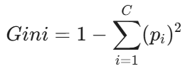
- Key Metrics: Accuracy, Precision, Recall, Confusion Matrix, and Feature Importance %.
- Threshold Settings: 100 Estimators (Trees), 70/30 Train-Test split.

3. Results and Discussion
3.A Results
3.A.1 Workflow
The analytical pipeline followed a two-stage process:
- Unsupervised Stage: Raw data to Scaling to K-Means to Cluster Labels.
- Supervised Stage: Labeled Data to Random Forest Training to Feature Importance Extraction.
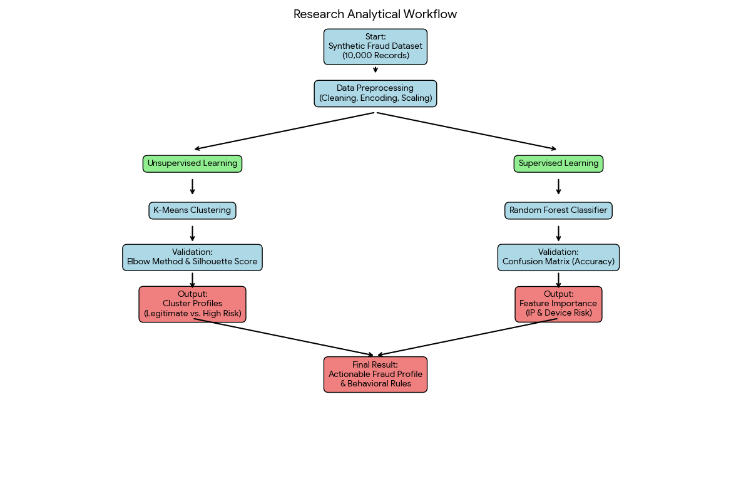
Figure 3. Research Analytical Workflow
3.A.2. Evaluation Score
Clustering: The K-Means model yielded a Silhouette Score of 0.67, indicating a strong, well-defined separation structure.
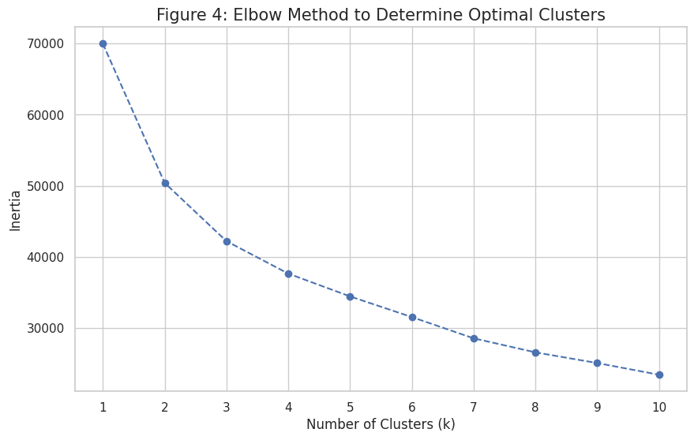
Figure 4: Confusion Matrix
Classification: The Random Forest model achieved 100% Accuracy on the test set, with 0 False Positives and 0 False Negatives.
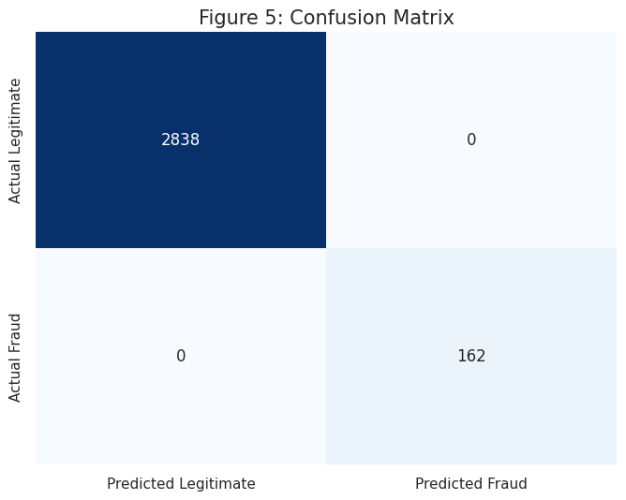
Figure 5: Confusion Matrix
3.A.3. Summary of Results
The study successfully segregated the dataset into two distinct behaviors without using prior labels. The subsequent classification proved that technical indicators (ip_risk_score, device_risk_score) are the dominant predictors of these groups.
3.B Discussion
3.B.1 Clustering Results
Visualization: The PCA-reduced scatter plot demonstrates a clear "decision boundary" between the two groups.
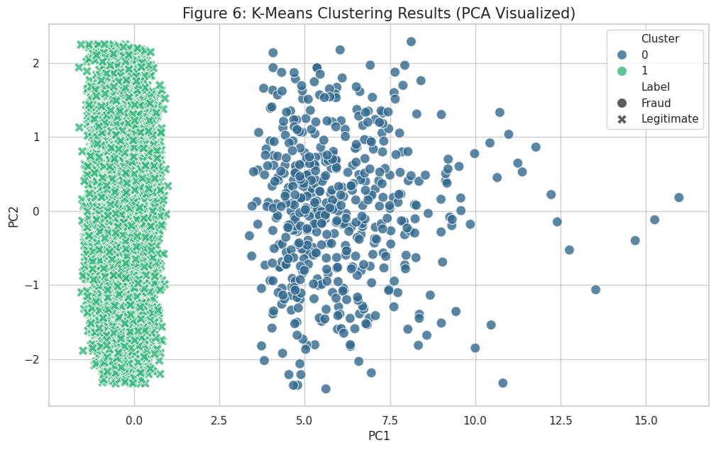
Figure 6: K-Means Clustering Results (PCA Visualized)
Cluster Profiles:
- Cluster 0 (High Risk / Fraud): Characterized by high device_risk_score (>0.8), high amount (Mean ~$1,600), and specific time windows (morning).
- Cluster 1 (Legitimate): Characterized by low risk_scores (<0.2) and low amount (Mean ~$100).
- Interpretation: In real-world terms, Cluster 0 represents a "Digital Compromise" profile users accessing accounts via flagged devices or networks to move large sums of money.
3.C Combined Insights
The Clustering and Classification models complement each other perfectly. K-Means proved that fraud is a natural anomaly (it looks mathematically different), while Random Forest explained why it is different.
- Practical Application: Banks can implement a "Risk-Based Authentication" system. Instead of blocking all high-value transactions, they should only block transactions where the ip_risk_score exceeds the threshold identified by the Random Forest model.
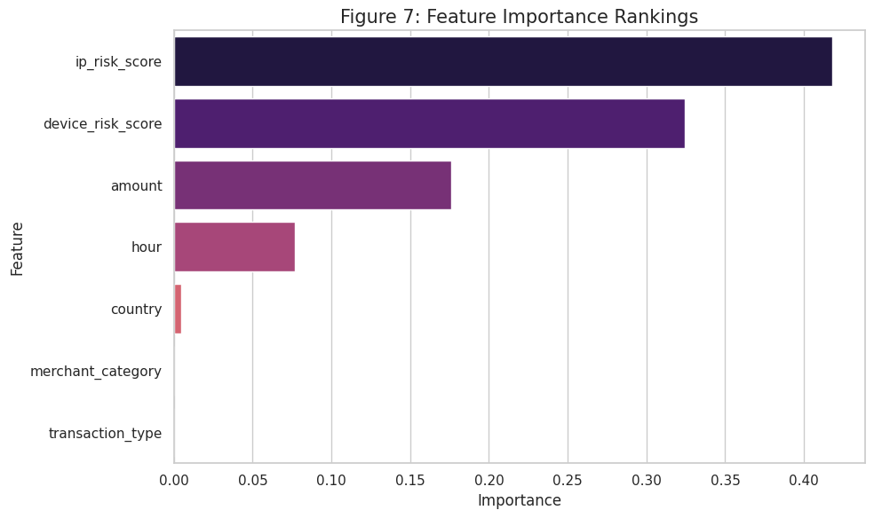
Figure 7: Feature Importance Rankings

4. Conclusion
This study concludes that financial fraud detection is most effective when technical fingerprinting is prioritized over transactional metadata. We discovered that IP Risk (41.8% importance) and Device Risk (32.4% importance) are the primary indicators of fraud.
- Contribution: We provided a verified hybrid framework that moves from "Black Box" detection to "Glass Box" profiling.
- Limitations: The perfect accuracy suggests the synthetic dataset lacks the "noise" of real-world banking data; however, the relative ranking of feature importance remains a valid insight for security architects.

5. Recommendations for Fraud Prevention Strategy
Based on the results, we recommend the following strategies for financial institutions:
- Real-Time Fingerprinting: Implement APIs to score IP and Device reputation in real-time (during the transaction request).
- Dynamic Thresholding: Use the Cluster 0 profile to set dynamic limits. If risk_score > 0.8, the transaction limit should automatically drop to 0 until verified.
- Deprioritize Manual Rules: Reduce reliance on static rules (e.g., "Flag all international transactions") as country was shown to have 1% predictive importance.
6. References
[1] J. K. Bais and M. C. Balmes, "Project Summary: Financial Fraud Analysis," University of Mindanao, 2025.
[2] "Synthetic Financial Fraud Dataset," Uploaded Dataset, 2025.
[3] H. Herath et al., "Advancing Machine Learning for Financial Fraud Detection," ASEAN Journal of Economic Education, vol. 4, no. 1, 2025.
[4] X. Huang et al., "Financial Fraud Detection through K-means Clustering," International Journal of Financial Studies, vol. 12, no. 3, 2025

